# INTERNATIONAL TournAMENTS

# COLD PLAY SHARKS Mechelen

**2017**

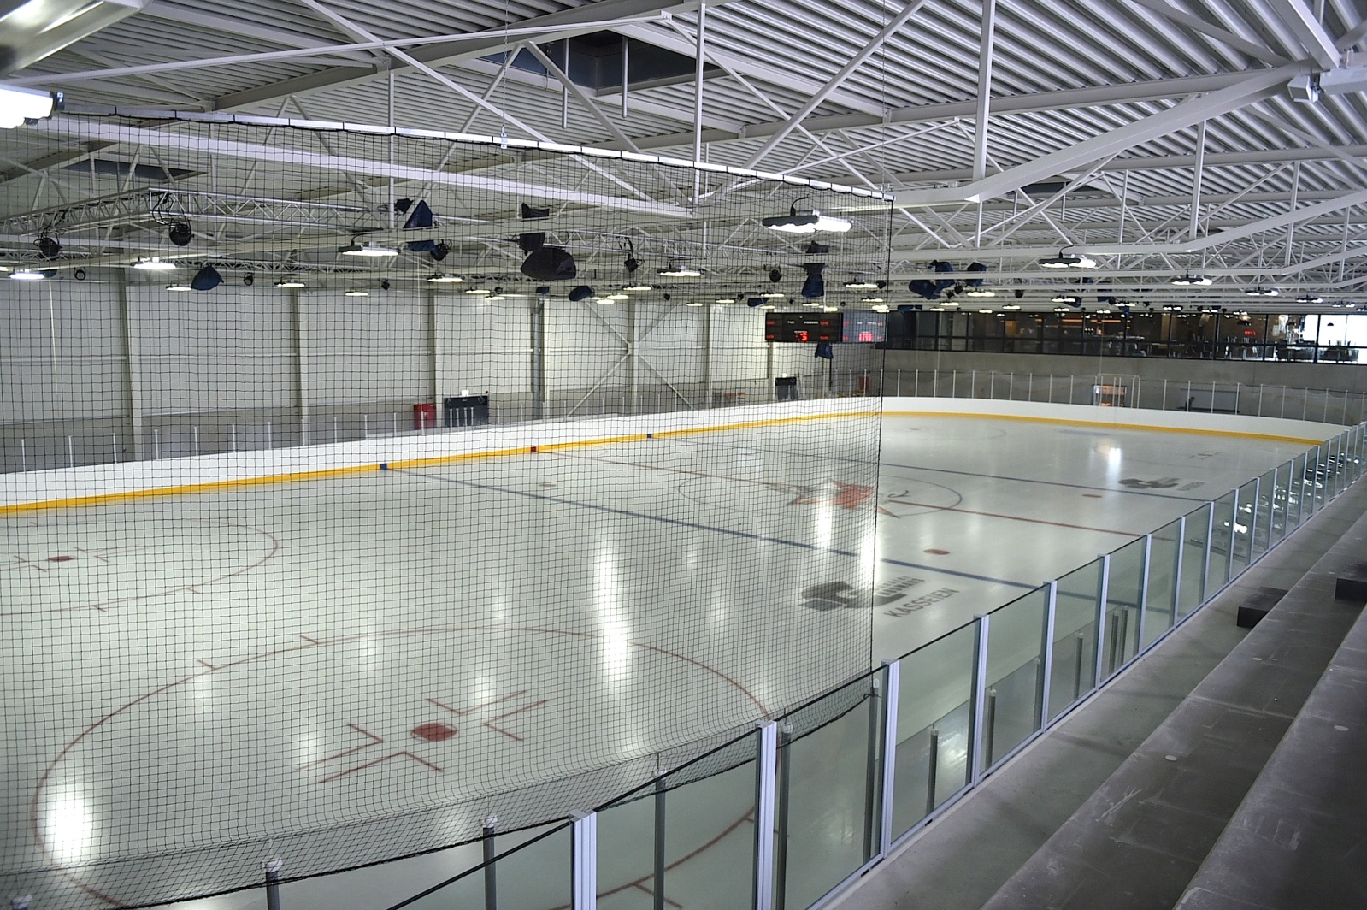

Mechelen, 11 december 2016

Dear ice hockey friends,

Cold Play Sharks Mechelen has the pleasure of inviting your team in a brand new ice-arena to our tournaments in 2017:

### International Tournament U8

Saturday 15 april 2017

### International Tournament U10

Sunday and Monday 16- 17 april 2017

### International Tournament U12

Saturday and Sunday 8-9 April 2017

### International Tournament U14

Saturday and Sunday 13-14 May 2017

### International Tournament U16

Saturday and Sunday 6-7 May 2017

### International Tournament U19

Saturday and Sunday 22-23 April 2017

**International REC Tournament**

Saturday and Sunday 20-21 may 2017

The organization:

⚫Games will be played on full ice. (except U8/U10 = cross-ice)

Participating teams can consist of maximum 17 players (15 players and 2 goalies, minimum 10 players and 1 goalie)

⚫ The cafeteria/restaurant at the ice-arena will be open during the entire weekend.

⚫ Every team will be responsible for damages caused on the premises.

⚫ The game schedule will be provided 6 weeks in advance.

⚫ Tournament Fee = 400,00 € for all tournaments except 200 € for U8 tournament (1 day)

⚫ Meals for players are not included. It is possible to have a pasta meal for the players and coaches for the price of 5 € p.p.

#### Be careful the places are limited, register as soon as possible

In order to book, please forward the registration form together with a down payment of 100 €.

Account: IBAN : BE07 3630 7125 8866 – BIC : BBRUBEBB

Best regards and hopefully see you soon,

**Cold Play Sharks Mechelen - info@coldplaysharks.be**

**Cold Play Mechelen vzw**

**Spuibeekstraat 1**

**2800 Mechelen**

**info@coldplaysharks.be**

**TEAM NAME : \_\_\_\_\_\_\_\_\_\_\_\_\_\_\_\_\_\_\_\_**

Color of jerseys n°1 : \_\_\_\_\_\_\_\_\_\_\_\_\_\_\_\_\_\_\_

Color of jerseys n°2 : \_\_\_\_\_\_\_\_\_\_\_\_\_\_\_\_\_\_\_\_

# TEAM ROSTER

|  |  |  |  |  |  |
| --- | --- | --- | --- | --- | --- |
| NAME | FIRST NAME | DATE OF  BIRTH | POSITION | C/A | NUMBER |
|  |  |  |  |  |  |
|  |  |  |  |  |  |
|  |  |  |  |  |  |
|  |  |  |  |  |  |
|  |  |  |  |  |  |
|  |  |  |  |  |  |
|  |  |  |  |  |  |
|  |  |  |  |  |  |
|  |  |  |  |  |  |
|  |  |  |  |  |  |
|  |  |  |  |  |  |
|  |  |  |  |  |  |
|  |  |  |  |  |  |
|  |  |  |  |  |  |
|  |  |  |  |  |  |
|  |  |  |  |  |  |
|  |  |  |  |  |  |
|  |  |  |  |  |  |
|  |  |  |  |  |  |
|  |  |  |  |  |  |

# Registration FORM

# INTERNATIONAL TournAMENTS Cold Play Sharks Mechelen

**2017**

Sending back to us before February 1st, 2017:

**CLUB NAME :**

address :

town:

Telephone n° club : \_\_\_\_\_\_\_\_\_\_\_\_\_

e-mail :

**COACH :**

Tel. :

Mobile N° :

E-mail :

**TEAM MANAGER :** tel. : \_\_\_\_\_\_\_\_

e-mail:

**TEAM MANAGER :** tel. : \_\_\_\_\_\_\_\_

e-mail:

We strongly recommend :



|  |
| --- |
|  |
|  |
| cid:image004.png@01D0C07B.9B5B59B0 |
| cid:image005.png@01D0C07B.9B5B59B0 Novotel Mechelen Centum |
| cid:image003.png@01D0C07B.9B5B59B0 Van Beethovenstraat 1, 2800 Mechelen, Belgium |
| cid:image003.png@01D0C07B.9B5B59B0 Tel : + 32 (0)15 40 49 53 cid:image006.png@01D0C07B.9B5B59B0Fax : + 32 (0)15 40 49 51 |
| cid:image002.png@01D0C07B.9B5B59B0 [**H3154-RE@accor.com**](mailto:H3154-RE@accor.com) [cid:image003.png@01D0C07B.9B5B59B0](mailto:prenom.nom@accor.com) [**novotel.com**](http://www.accorhotels.com/) cid:image003.png@01D0C07B.9B5B59B0 [**accorhotels.com**](http://www.accorhotels.com/) |
| cid:image007.png@01D0C07B.9B5B59B0 |
|  |
| cid:image007.png@01D0C07B.9B5B59B0 |

Prices : Single Room, breakfast incl. 85 Euro room/night

Double Room, breakfast incl. 95 Euro room/night

Triple Room, breakfast incl. 105 Euro room/night

City tax 3,40 Euro room/night

**Reservations** should be made **directly with the hotel** and make the communication « **Cold Play Sharks Tournament** «

Please ask the prices for lunch or diner in the hotel.

The hotel is fully booked in the weekend 15,16 and 17 april 2017 (U8/U10 tournament)

Best regards,

|  |  |  |
| --- | --- | --- |
| **Laurens Luykx** Cold Play Sharks Mechelen  Operational Manager | | |
|  | | |
| **M**: +32.497.44.93.42 **E**: [laurens@coldplaysharks.be](mailto:laurens@coldplaysharks.be) | | |
|  | | |
| 2000000121-ColdPlay_2-768x783.jpg |  | **Cold Play Sharks** Spuibeekstraat 1  B-2800 Mechelen  [www.coldplaysharks.be](http://www.coldplaysharks.be) |